NAME: ……………………………………………………………………………………………

SCHOOL:…………………………………………………….INDEX NUMBER………………

CANDIDATE’S SIGN …………………………………………..DATE:………………………

232/3
PHYSICS
PAPER 3(PRACTICAL)
JUNE 2022
TIME: 2 ½ HRS

MOMALICHE JUNE 2022
Kenya Certificate of Secondary Education (K.C.S.E)

INSTRUCTIONS TO CANDIDATES
Answer all the questions in the spaces provided in this question paper.
You are supposed to spend the first 15 minutes of the 2 ½ hrs allowed for this paper reading the whole paper carefully before commencing your work.
Marks will be given for clear record of the observations actually made, their suitability, accuracy and the use made of them.
Candidates are advised to record their observations as soon as they are made.
Non-programmable silent electronic calculators and KNEC mathematical tables may be used.

FOR EXAMINERS USE ONLY.

QUESTION 1

NO. | a, b | c | TOTAL
MAXIMUM SCORE | 14 | 6 | 20
CANDIDATES SCORE

QUESTION 2

 | a | b | c | d | f | g | h | i
maxmum score | 1 | 1 | 1 | 2 | 6 | 4 | 2 | 3
Candidate’s scores
GRAND TOTAL

Question 1 (20 marks)
You are provided with the following
-Two dry cell
-One bulb
-Voltmeter (0 – 3V)
-Ammeter (0 – 1A)
-Amounted nicrome wire mounted on a millimeter scale
-Switch
-Seven connecting wire at least two with crocodile clips
-Micrometer screw gauge
Proceed as follows:
- i). Set up the circuit as shown in the figure 1 below.
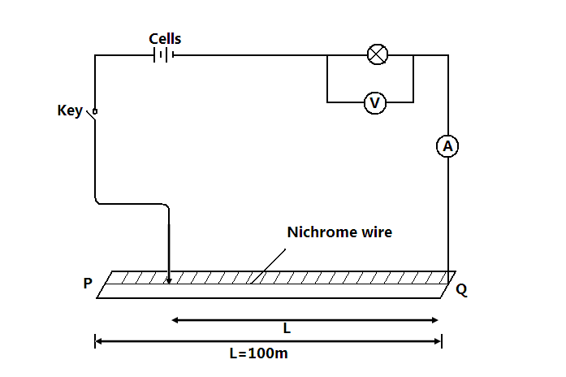
ii) With the crocodile clip at p, take the voltmeter reading and ammeter reading. Record v and 1 repeat the readings for L=80, 60, 40, 20 and 0cm respectively and complete the table below. (5mks)

Length, L(cm) | 100 | 80 | 60 | 40 | 20 | 0
Voltage, V(V)
Current, I (A)

iii). What changes do you observe on the bulb as L decreases from p? (1mrk)
………………………………………………………………………………………………………………………………………………………………………………………………………………………………………………………………………………………………………………………………………………

iv).Plot a graph of ammeter reading (y=axis) against voltmeter readings. (5mrks)

v). Determine the slope of the graph at V=1 volt. (2mrks)

vi). What physical quantity is represented by the slope of the graph at any given point? (1mrk)

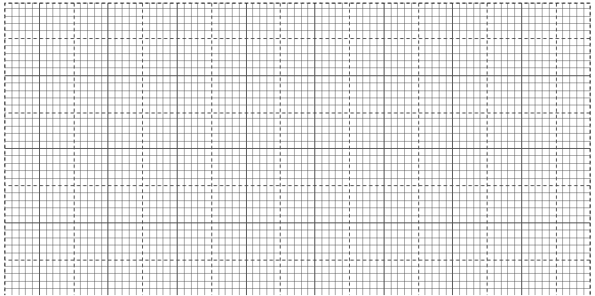



b. (i) Given the apparatus in a (i) above, draw a diagram of the circuit you would use to determine the current through the resistant wire and the potential difference across. (1mrk)

ii).Set up the circuit you have drawn. Record the ammeter reading I and the wire reading V when L=100cm (2mks)

V=…………………… I=………………………………………..

iii). Using a micrometer screw gauge, measure the diameter of the wire. (1mrk)

d=……………………………………………m

iv). Calculate the quantity:
p= 0.785 $\frac{(V)}{I}\frac{d^{2}}{L}$and give its units, where L is one meter. (2mrks)

Question 2
You are provided with the following:-
- Vernier callipers
- Micrometer screw gauge
- Masses; 10g, 20g, 50g and 100g
- A helical spring
- Metre rule or half metre rule

Proceed as follows
- Determine the number of complete turns of the helical spring.
N = _______________________ (1 Mark)
- Measure the external diameter of the spring using the vernier callipers
D = _______________________ m (1 Mark)
- Use the micrometer screw gauge to determine the diameter of the wire of the spring.
d = ______________________ m (1 Mark)
- Determine the value of m (2 Marks)
N = $\frac{0.4D}{dm}$
……………………………………………………………………………………………………………
……………………………………………………………………………………………………………
……………………………………………………………………………………………………………
- Suspend the helical spring vertically alongside the clamped half metre rule as shown in figure 1 below. Determine the length L₀, of the spring before loading it.
L₀ = __________________ cm
Stand
Half metre rule

Figure 2
- Load the spring with a mass of 20g and determine the new reading on the metre rule. (L) Record this in the table below.

- Calculate the extension e = L – L₀ due to the mass of 20g and record the value in the table given below. Repeat step f for other masses and complete the table.

Mass (g) | 0 | 10 | 20 | 30 | 40 | 50 | 60 | 70 | 80 | 90 | 100
Weight (N)
Reading (L) (cm)
Extension e (cm)
$\frac{1}{e}$ (cm⁻¹)
(6 Marks)

- Plot a graph of weight (N) against $\frac{1}{e}$ (cm⁻¹) (4 Marks)




- Determine the slope (s) of the graph at a mass of 45g (2 Marks)

……………………………………………………………………………………………………………
……………………………………………………………………………………………………………

- Given that m = $\frac{-255T}{{(S+60)}^{2}}$
Determine the value of T where (S) is the slope at 45g (3 Marks)
……………………………………………………………………………………………………………
……………………………………………………………………………………………………………
……………………………………………………………………………………………………………
……………………………………………………………………………………………………………

